Experiment Number: 2
MATLAB Simulation of Cellular Coverage, Cell Splitting and Handoff in a Multi-Cell Network
Aim
To model a simplified hexagonal cellular network and study how cell radius affects coverage,
estimated user capacity and handoff as a mobile crosses a cell boundary.
Objectives
By the end of the experiment, students should be able to:
1. Model adjacent hexagonal cell coverage and identify cell centers and boundaries.
2. Estimate the number of cells required to cover a fixed service area for different cell radii.
3. Compare estimated users served under an explicit per-cell capacity assumption.
4. Simulate a mobile moving across a cell boundary and identify the serving-cell transition.
Requirements
• Computer with MATLAB R2019b or later.
• No RF hardware is required; this is a geometric and analytical simulation.
Theoretical Background
- A regular hexagonal cell is an idealized coverage region. For cell radius R, measured from
- the centre to a vertex, its area is A_cell = (3√3/2)R2.
- A first-order estimate for a service area A is N_cells = ceil(A/A_cell).
- This area ratio ignores boundary overlap, roads, terrain, irregular coverage and the fact that real cell layouts extend beyond the service boundary.
- For a simple capacity comparison, assume each cell can serve C users at the same time.
- Estimated network capacity is N_cells × C. This is a planning illustration, not a prediction of
- a real network; capacity also depends on spectrum, scheduling, traffic, interference, backhaul
- and radio conditions.
- For handoff, the serving cell is approximated as the cell centre nearest to the mobile. A
- handoff is indicated when the nearest-centre identity changes. Real systems use measured
- radio quality, hysteresis, time-to-trigger, load and network policy, so this geometric rule is only a teaching model.

Parameters and Assumptions
1. Service Area: 5 km² — The total geographical area to be covered by the idealized cellular layout.
2. Cell Radii: 1.0 km and 0.5 km — The baseline cell radius is 1.0 km, while the split-cell scenario uses a reduced radius of 0.5 km.
3. Per-Cell Simultaneous-User Capacity: 30 users per cell — The same assumed capacity is maintained for each cell in both scenarios to isolate the effect of increasing the number of cells.
4. Handoff Geometry: Two adjacent cells — The mobile user follows a straight-line path across the shared boundary between two neighbouring cells.
5. Changed Values: Any values modified from the baseline assumptions must be explicitly recorded.
Procedure
1. Run the MATLAB script below and record the cell area, estimated cell count and total
illustrative capacity for each radius.
2. Inspect the hexagonal layout and confirm that adjacent cells share edges without gaps in
the idealized tiling.
3. Inspect the mobile-path plot and note the simulated handoff point.
4. Change the service area, radii or users-per-cell assumption one at a time; rerun and
compare results.
5. Explain why the geometric cell count and nearest-center handoff differ from an
operational cellular network.
MATLAB Program — Coverage, Cell Splitting and Handoff
% Experiment 2: simplified hexagonal coverage and handoff
clear; clc; close all;
% Baseline assumptions
serviceAreaKm2 = 5;
radiiKm = [1.0 0.5];
usersPerCell = 30;
hexArea = @(R) (3*sqrt(3)/2) .* R.^2;
cellAreaKm2 = hexArea(radiiKm);
cellCount = ceil(serviceAreaKm2 ./ cellAreaKm2);
estimatedUsers = cellCount .* usersPerCell;
capacityTable = table(radiiKm(:), cellAreaKm2(:), cellCount(:), ...
repmat(usersPerCell,numel(radiiKm),1), estimatedUsers(:), ...
'VariableNames', {'Radius_km','CellArea_km2','EstimatedCells', ...
'UsersPerCell','IllustrativeUsers'});
disp(capacityTable);
% Plot a 7-cell cluster: central cell plus six neighbors
R = radiiKm(1);
centers = [0 0; 1.5*R sqrt(3)*R/2; 1.5*R -sqrt(3)*R/2; ...
0 sqrt(3)*R; 0 -sqrt(3)*R; -1.5*R sqrt(3)*R/2; ...
-1.5*R -sqrt(3)*R/2];
theta = (0:6)*pi/3; % flat-top hexagon vertices
figure; hold on; axis equal; grid on;
for k = 1:size(centers,1)
plot(centers(k,1)+R*cos(theta), centers(k,2)+R*sin(theta), 'k-');
text(centers(k,1),centers(k,2),sprintf('Cell %d',k), ...
'HorizontalAlignment','center');
end
xlabel('x (km)'); ylabel('y (km)');
title('Idealized Seven-Cell Hexagonal Cluster');
hold off;
% Mobile moves across the boundary between centers at x=0 and x=1.5R
mobileX = linspace(-0.2*R,1.7*R,300);
mobileY = zeros(size(mobileX));
d1 = hypot(mobileX, mobileY);
d2 = hypot(mobileX-1.5*R, mobileY);
servingCell = ones(size(mobileX));
servingCell(d2 < d1) = 2;
handoffIndex = find(diff(servingCell) ~= 0,1,'first') + 1;
figure; hold on; grid on;
plot(mobileX,d1,'LineWidth',1.5);
plot(mobileX,d2,'LineWidth',1.5);
if ~isempty(handoffIndex)
xline(mobileX(handoffIndex),'--r','Handoff decision');
end
xlabel('Mobile x-position (km)'); ylabel('Distance to cell center (km)');
legend('Cell 1','Cell 2','Location','best');
title('Nearest-Center Handoff Approximation');
hold off;
figure; stairs(mobileX,servingCell,'LineWidth',1.5); grid on;
xlabel('Mobile x-position (km)'); ylabel('Serving-cell ID');
title('Serving Cell Along the Mobile Path');
if ~isempty(handoffIndex)
fprintf('Geometric handoff at x = %.3f km\n',mobileX(handoffIndex));
end
Result
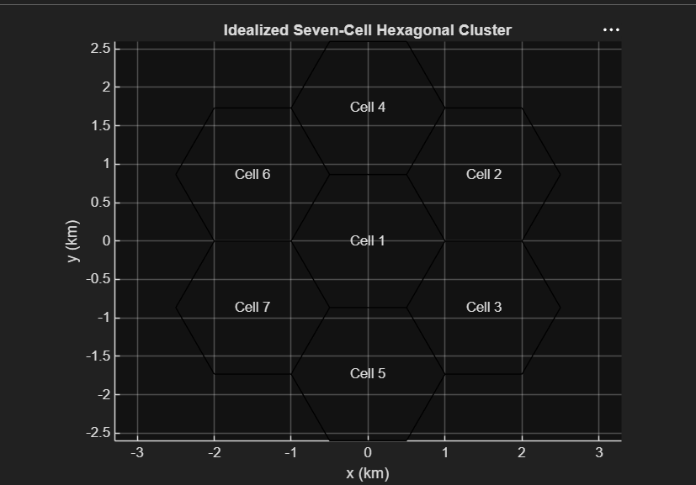
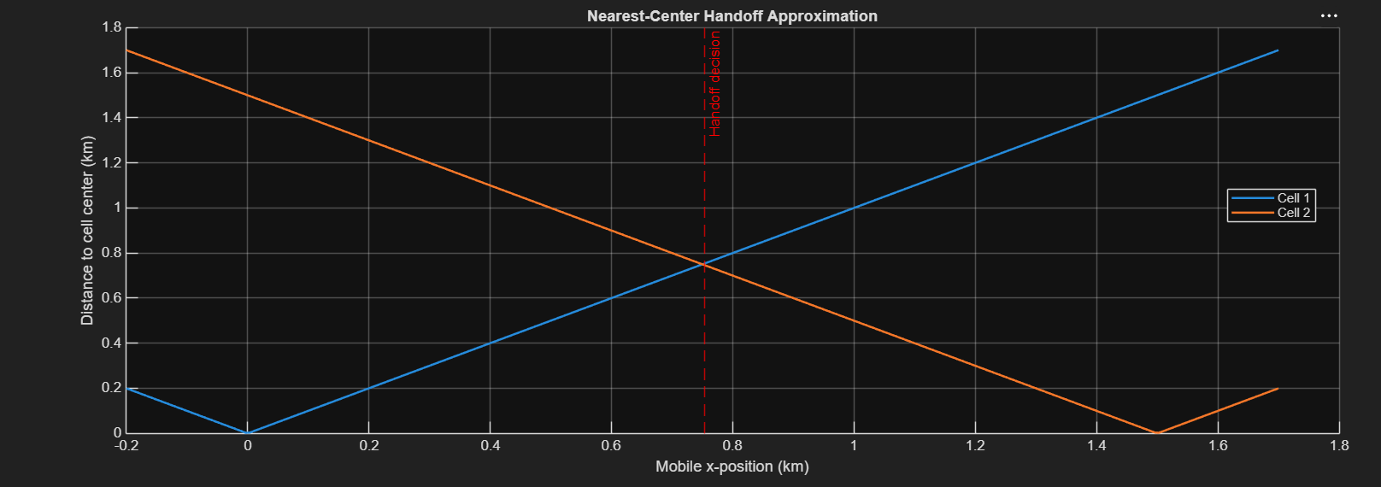
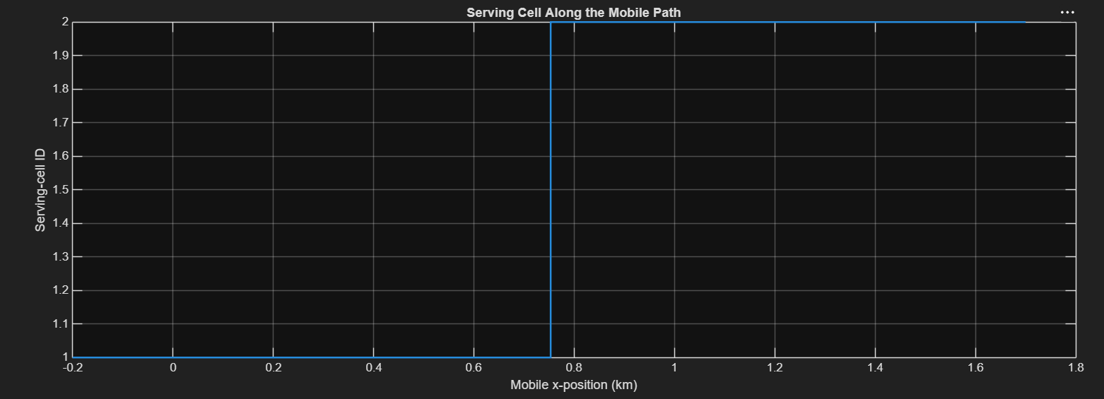
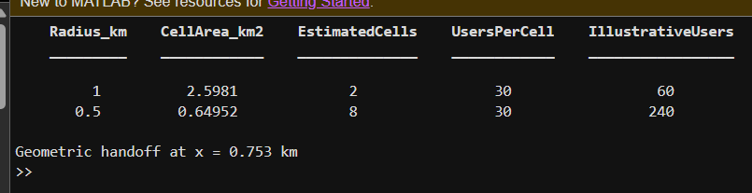
Conclusion
Summarize how cell radius changes the idealized cell count and assumed network capacity,
and report the simulated handoff location. State that the model uses ideal hexagons, an area-
ratio count, fixed per-cell capacity and nearest-centre handoff; it does not model RF
propagation, overlap, fading, load or handoff timers.

